EML 4905 Senior Design Project

A b.s. tHESIS
Prepared in Partial Fulfillment of the
Requirement for the Degree of
Bachelor of Science
in
Mechanical Engineering

Exhaust Driven Turbine
100% Final Report

Brian Gleason
Angel Fernandez
Efrain Rivero

Advisor: Professor Andres Tremante

April 3, 2014

This B.S. thesis is written in partial fulfillment of the requirements in EML 4905. The contents represent the opinion of the authors and not the Department of Mechanical and Materials Engineering.

Ethics Statement and Signatures

The work submitted in this B.S. thesis is solely prepared by a team consisting of Brian Gleason, Angel Fernandez, and Efrain Rivero and it is original. Excerpts from others’ work have been clearly identified, their work acknowledged within the text and listed in the list of references. All of the engineering drawings, computer programs, formulations, design work, prototype development and testing reported in this document are also original and prepared by the same team of students.

Brian Gleason  Team Leader | Angel Fernandez  Team Member | Efrain Rivero  Team Member
Dr. Andres Tremante
Faculty Advisor

Table of Contents
List of Figures v
List of Tables vii
Table of Equations vii
Abstract 1
Introduction 2
Problem Statement 2
Design Objectives 3
Motivation 4
Literature Survey 4
Market Analysis 4
Faraday’s Law Research 7
Similar Research 7
Initial Conceptual Design 9
Proposed Design 9
Initial Design Alternative 1 11
Initial Design Alternative 2 13
Initial Design Alternative 3 15
Initial Design Alternative 4 16
Initial Helical Design Concepts 18
Initial Helical Design 1 18
Initial Helical Design 2 20
Initial Helical Design 3 22
Test Data & Manufacturing of Initial Helical Designs 23
Manufacturing 25
Preliminary Final Designs & Testing 27
Apparatus 27
Bearing Used In Testing of Turbine A and Turbine B 28
Turbine A 29
Testing of Turbine A 31
Turbine B 34
Testing of Turbine B 35
Final Design 39
Bearing Used In Testing of Turbine 41
Testing of Final Turbine Design 41
Transfer of Electrical Power 47
Flow Rates 49
Project Management 55
Timeline 55
Major Components 56
Blade Material Selection 56
Structure Material Selection 57
Copper Coils 57
Magnets 58
Structural Design 58
Cost Analysis 59
Prototype 61
Cost Analysis 61
Testing Plan 62
Conclusion 63
References 65

List of Figures
Figure 1 - Where the Energy Goes 3
Figure 2 - Hybrid-Electric Vehicle Sales in the U.S. 6
Figure 3 - Axial Exhaust Turbine 12
Figure 4 - Constant Volume Flow Analysis 13
Figure 5 - Alternate Design 1 - Two 180° blades 14
Figure 6 - Alternate Design 1 - Axial View 15
Figure 7 - Alternate Design 2 - Perpendicular axis of rotation 16
Figure 8 - Alternate Design 3 17
Figure 9 - Alternate Design 3 - Top View 17
Figure 10 - Isometric View of Helical Design 1 19
Figure 11 - Front View of Helical Design 1 20
Figure 12 - Isometric View of Helical Design 2 21
Figure 13 - Front View of Helical Design 2 21
Figure 14 - Isometric View of Helical Design 3 22
Figure 15 - Front View of Helical Design 3 23
Figure 16 - 3-D Printed 6 Blade Design 24
Figure 17 - 3-D Printed 4 Blade Design 24
Figure 18 - Front View of Design 26
Figure 19 - Isometric View of Design 26
Figure 20 - Apparatus (Technavate Vari-speed multi-fan Distribution Apparatus) 27
Figure 21 - Bearing attached to pipe 30
Figure 22 - Testing Pipes and Bearing 30
Figure 23 - Turbine A 31
Figure 24 - Pitot Tube Used for Experiment 32
Figure 25 - Testing of Turbine A 33
Figure 26 - Turbine B 35
Figure 27 - Pressure Difference Between Turbine A and Turbine B 36
Figure 28 - Comparison of Printed 3-D Models (Inlet of Turbine A and Turbine B) 37
Figure 29 - Comparison of Printed 3-D Models (Outlet of Turbine A and Turbine B) 38
Figure 30 - Final Designed Turbine on SolidWorks 39
Figure 31 - 3-D Printed Final Design Turbine 40
Figure 32 - Bearing Used in Final Assembly 41
Figure 33 - Pressure Comparison Before and After Adding the Turbine 43
Figure 34 - Relation of RPM's vs. Amps 44
Figure 35 - Velocity at 56mm Pipe as the Amps Increased 46
Figure 36 - Reynolds at 56mm Pipe as the Amps Increased 46
Figure 37 - Coil outside the Turbine to Determine Current 48
Figure 38 - Model of Final Assembly on Solid Works 52
Figure 39 - Final Assembly of Turbine Housing 52
Figure 40 - Final Assembly of Turbine Design 53
Figure 41 - Apparatus for Final Assembly Testing 54
Figure 42 - Project Timeline 55

List of Tables
Table 1 - Bearing A Specifications 28
Table 2 - Gathered Data of Pressure without Turbine 33
Table 3 - Gathered Data of Pressure with Turbine (A) 34
Table 4 - Gathered Data of Pressure with Turbine (B) 35
Table 5 - Pressure in Inches of Water before Turbine is Added 42
Table 6 - Pressure in Inches of Water after the Turbine is added 42
Table 7 - RPM Readings for Turbine with Different Air Flows 44
Table 8 - Calculated Velocity and Reynolds for Diameter of 56mm Pipe 45
Table 9 - AC Voltage Readings of One Coil 49
Table 10 - Air Distribution System Volume Flow Rates 49
Table 11 - Engine Volume Flow Rates 50
Table 12 - Electrical Outputs in Different Coil Configurations 51
Table 13 - Electrical Output at Maximum Speed and Magnetism 54
Table 14 - Prototype Materials 60
Table 15 - Engineering hours 60

Table of Equations
Equation 1 - Velocity of air flow 45
Equation 2 - Reynolds Number 45

Abstract
There is a desire worldwide to increase the efficiency of gasoline internal combustion engines in order to decrease emissions and to counter the increasing prices of gasoline. One main challenge in all designs is the decrease of wasted energy or wasted material. In the case of engines, there is wasted energy in the form of heat and exhaust gases. Our project will focus on capturing the energy from wasted exhaust gas without creating inefficiencies in the engine.
A system will be designed to be implemented in existing gasoline exhaust pipes to capture wasted energy. A turbine with its axis of rotation along the direction of exhaust gas flow will be placed near the exit of the exhaust pipe and connected to a battery. Electricity generated from the system will be stored in the battery and can be used in addition to electrical loads currently generated from gasoline engines.
Utilizing Faraday’s Law of Induction, the system will transmit power from the velocity and pressure of exhaust gas by housing magnets in the turbine walls and attaching copper coils to an external enclosure. The disruption in the magnetic field within the copper coil will induce a current in the coil.

Introduction

Problem Statement
Design a system to capture energy from engine exhaust gases to be used in conjunction with existing gasoline-electric hybrid engine systems. The system should introduce a minimal amount of exhaust back pressure to avoid decreasing efficiency and power output of the gasoline engine.
Waste is a major concern in any type of production whether it’s in manufacturing, engines, or even a business process. Waste elimination is a process undergone while designing systems, but waste can only be reduced to a certain point until it is not cost effective to proceed. Introducing a new system to capture this excess waste would not necessarily reduce the waste from the original system, but would make better use of the waste and create an overall more efficient system.
According to a study done by the U.S. Department of Energy, between 14%-30% of the gas you would put into your car’s tank is actually used to move the automobile down the road. All the rest of the energy is lost in the internal combustion engine as well as other inefficiencies. It is our goal to drastically improve the development in advanced technologies in fuel efficiency in the automobile industry. Figure 1 shows where the energy is used up in a conventional vehicle and with this there are many areas of opportunity in which we can improve upon (Where The Energy Goes, 2007). It’s been over a century of engine manufacturing and as a civilization we have only obtained up to 40% efficiency in engines. It is our initiative to continue to take strides into making a more efficient system.

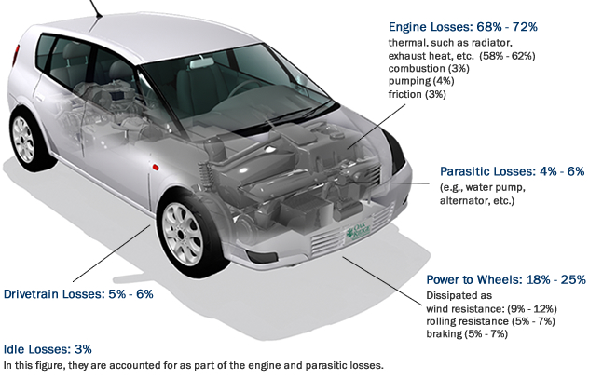
Figure 1 - Where the Energy Goes

Design Objectives
The objective is to design a cylindrical turbine to be placed in the exhaust pipe of an engine. The axis of rotation of the turbine is to be along the direction of flow of exhaust gases allowing the design to introduce as little pressure as possible. Increasing the amount of pressure in the exhaust pipe by a negligible amount will allow the engine to perform as expected and without a decrease in efficiency.
A cylindrical turbine will be placed at the exit of the existing exhaust pipe. The turbine will have a slightly larger diameter than that of the exhaust pipe, and will connect to the exhaust pipe using a bearing. The blades will line the interior of the cylinder, and the exterior will be lined with magnets to ultimately create a magnet generator. An enclosure will be placed around the rotating cylinder with copper coils. The rotation of the magnets on the cylindrical turbine induces a current in the copper coil, which can be captured in a battery.

Motivation
Waste utilization is the main inspiration behind this design. With limited capabilities behind the reduction of waste from a gasoline engine, creating a new system to utilize the wasted energy is the next step to further increase efficiency.
In 2013, The Obama Administration finalized groundbreaking standards that will increase fuel economy to the equivalent of 54.5 mpg for cars and light-duty trucks by 2025 (NHTSA, 2012). Gasoline-Electric Hybrid engines have proven to be a large step towards greatly increasing the mileage of cars. The exhaust-driven turbine will provide assistance in charging the battery used to power the electric motor, further increasing fuel efficiency.

Literature Survey

Market Analysis
The market our product is intended for is the automobile industry and more specifically vehicles utilizing hybrid engines. The use of the different power sources such as the electric motor and the internal combustion engine make the design very unique and will provide the consumers with higher mileage than a conventional vehicle. The intention is to use the designed turbine to gather the energy from the exhaust gases flowing out of the car in the exhaust pipe. This energy will ultimately charge the batteries for the electric motor.
The Environmental Protection Agency’s regulatory announcement in August of 2012 states that between 2017 and 2025, cars manufactured will have to meet the 54.5 mpg standards (NHTSA, 2012). Since these regulations will exist, car manufacturers will have to make fuel economy improvements in order to meet the standards. This is a great opportunity for the exhaust turbine to be used in the improvement of the fuel efficiency. Figure 2 shows the trend of sales in hybrid-electric vehicles in the United States and as well as the involvement of many auto manufacturers (Alternative Fuels Data Center). It also shows the most popular selling car is the Toyota Prius since its release, but our design is targeted to give U.S. car manufactures an increased share into the market.

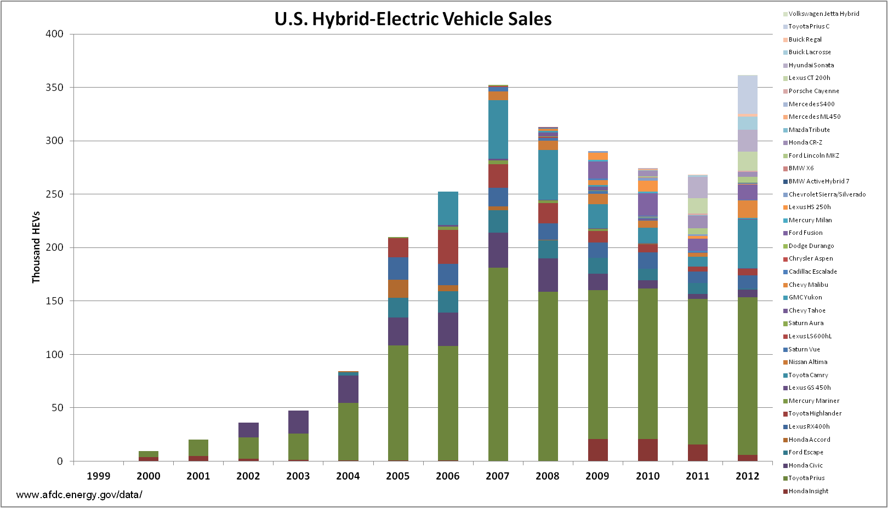
Figure 2 - Hybrid-Electric Vehicle Sales in the U.S.

Faraday’s Law Research
Michael Faraday’s revolutionary discoveries are the main emphasis in the inspiration behind the design and project. His contributions into the field of electromagnetism have paved the way into many technological advances that exist today and will come in the future. His discoveries in electromagnetic induction are at the heart of our focus in generating electricity with the turbine that will be incorporated into an exhaust pipe. A spinning magnet creates a force field that pushes electrons in a wire, which in our case would be a copper wire coil, generating an electrical current (Freedman & Young, 2004).

Similar Research
As our team performed an initial investigation on finding other research and product developments that were similar to our initial proposal, we came across a company named Aeristech. This company, hosted in the UK, created a comparable concept through the use of a turbocharger. For many years, this company has been developing a new approach to utilize a turbocharger more efficiently in order to boost the performance of automobile engines. Through their research, they have developed a product called the Full Electric Hybrid Turbocharger, which utilizes state-of-the-art fast accelerating permanent magnet motors to generate electric power from the turbo turbine through a split design. The electricity generated is stored onto a hydrogen fuel-cell battery in order for the turbo compressor to be driven separately from the turbo turbine through the battery directly (Aeristech, 2012). In this manner, turbo lag, which is a typical initial throttle response problem in most turbochargers, can be avoided by controlling the compressor separately and powering it at the right amount when it’s needed.
The concept of capturing the exhaust energies through Aeristech’s split design turbocharger is similar to our concept in the notion that the turbocharger turbine is driving directly the generation of electric power. For our proposed design of using helical blades, we will take the similar approach of generating electric power from the velocity of the exhaust gas. The design will also include a factor of developing an optimal blade design that can produce the least amount of back pressure for maximum efficiency. The difference in our design as compared to Aristech’s turbocharger design is based on the usage of the electric power being generated. The Full Electric Hybrid Turbocharger is designed convert the turbocharger spinning speed into electric energy to then power directly an electric air compressor to boost intake of the engine. The purpose of our helical design would to store the electric energy generated onto a battery that can later be used to give additional power to an electric system such as in the case of a hybrid powertrain.
Upon further investigating the topic of recovering energy from the exhaust gas, our team came across U.S. and European patents (Kawamura, 1987). The patents described an exhaust energy recovery device which utilizes a turbine rotatable by the exhaust gas in order to drive an electric magnet motor to generate electric power. This design is similar to our proposed method of capturing the kinetic energy from the exhaust gas as the rotating speed of the blade is being used to power an alternator. One key difference in comparison to our design is the type of blade that is being used. The patent schematic displays a rotary blade in resemblance to a turbocharger blade that directs the flow of the gases from entering tangentially to exiting the blade axially. In their particular design, the flow of the exhaust gas goes through a change in direction, producing a higher level of back pressure. For our proposed design, the blades will be formed in a shape that will allow for the flow of gas to enter and exit through the same axis, causing less back pressure to the system and allowing for an increase in the overall efficiency.

Initial Conceptual Design

Proposed Design
As the blades of the turbine have been developed to capture the kinetic energy of the gas flow, our engineers needed to create a system where the torque created by the exhaust gas can be converted directly into electrical energy to transfer the power generated. Instead of designing and connecting gears and running a generator to power up a battery, a more direct approach will be used by attaching magnets and coils that will induce current through the wires based on the general principles of Faradays’ law of induction. The electromagnetic induction is produced by creating a potential difference, also known as voltage, across the wires as it is exposed to a magnetic field that varies over time. In order to produce the changing magnetic fields, strong magnets will be designed to travel in a rotating motion to simulate the effect of the fields changing just as found in electric motors. These magnets will be attached along the surface of the inner rotating cylinder and will be in close proximity to specific coils of copper that will be weaved along the outer surface of the enveloping cylinder. The specific coil outline and configuration will resemble the pattern that is similarly found in AC/DC electric generators. The materials for the magnets placed in the armature will be neodymium based in order to provide the strongest induction onto the wires.
The inner cylinder which houses the blades of the turbine will be suspended inside the outer casing using a large bearing at one end. The final design will have two bearings at the entrance side of the turbine for stable cantilever support. The outer casing, which holds the coils, will be connected directly onto the exhaust tail pipe using a screw clamp for rigid support and will remain stationary in order for the rotating magnets to induce current into the fixed coils. For the AC configuration of the wires, a small converter will be connected to the battery in order to charge properly with DC current. The whole turbine system will be placed at the end of the exhaust tailpipe of an automobile car in order to avoid disrupting the calculated flow of the exhaust gas in between the exhaust system. In this manner, the prototype will be able to produce additional energy from the escaping energy of the gas that would otherwise be wasted as it exits into the air.
The blades that have been shaped out along the inner surface of the inner rotating cylinder have been designed in a helical shape with a 90 degree rotation change at each blade’s end so the flow of the engine gas would be least restricted as it exits the system. The helical design of only four blades will also prevent any larger amount of back pressure from building up in the system so that the engine’s performance would not be hindered by the attachment of the prototype. In order to help the performance of the turbine, a nozzle component will be connected to the upstream side of the exhaust gas before it enters the turbine section so that the speed of the flow can increase and be used more effectively to spin the blades. The nozzle will be made by using a gradual degree change, which will also evade any significant amount of increase in back pressure to the beginning of the exhaust pipe.

Initial Design Alternative 1
The main design alternative entails a helical axial turbine with the axis of rotation along the direction of the flow of exhaust gases. This design will allow for minimal pressure to be introduced into the system. Figure 3 shows a three dimensional model of the proposed design in a three inch diameter pipe. Two structural columns will be used to support each end of the helical blade’s central shaft. Miniature bearings will be placed at each of these joints to minimize friction. In order to transfer the angular velocity of the blades to electrical power, our design will include a bevel gear connection to one side of the blade axis that can redirect the torque of the center shaft downward where it can be connected to an electric generator from outside of the pipe area.

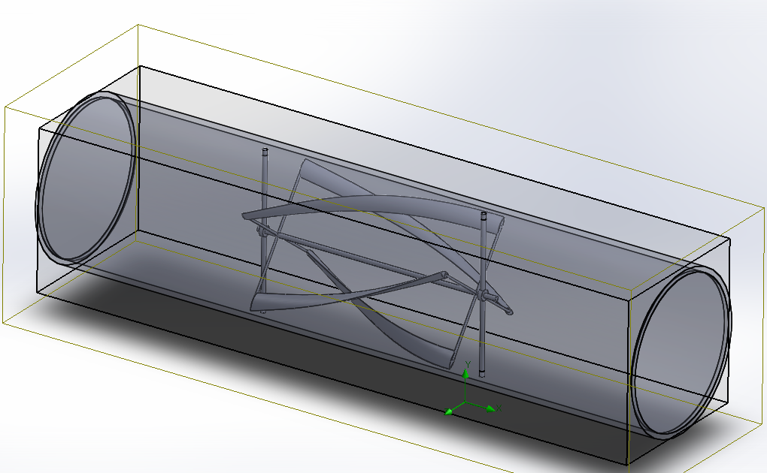
Figure 3 - Axial Exhaust Turbine

The proposed turbine design has four blades which each cover a ninety degree rotation along the length of the axis of rotation. The blades have been designed to cover the full three inch diameter pipe to allow for the greatest torque to be applied by the exhaust gases.

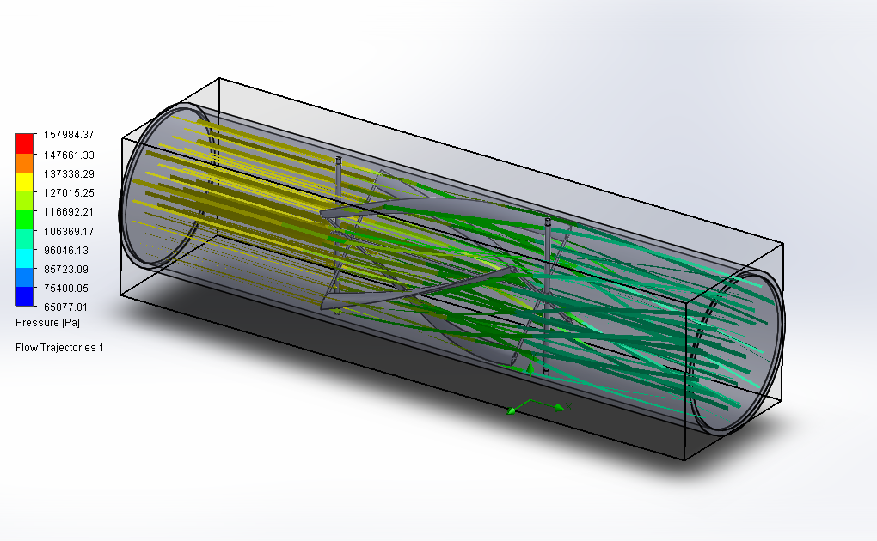
Figure 4 - Constant Volume Flow Analysis

Figure 4 shows a fluid analysis of the proposed design in a static setting. This simulation represents initial air flow or sudden increases in flow in which the turbine is spinning at a slow speed relative to the expected speed at steady state.
Alternate designs such as a turbine with a perpendicular axis of rotation or one with different blade patterns were considered.

Initial Design Alternative 2
The second design alternative includes a similar configuration to the proposed design. The model features two blades which cover a 180 degree rotation along the length of the axis of rotation. This design requires steeper blade profiles to cover the degree of rotation, which increases resistance as they are further from parallel to the direction of air flow.

Figure 5 - Alternate Design 1 - Two 180° blades
Figure 6 - Alternate Design 1 - Axial View

The model of this alternate design can be seen in Figure 5 and Figure 6. The axial view of the turbine shows the full 360° coverage necessary to capture as much energy as possible.

Initial Design Alternative 3
The third alternate design is a turbine with the axis of rotation perpendicular to the direction of air flow. This design was decided against due to the resistance while the gas hits the rear of the blades. Although the turbine can be optimized to be more effective on one particular side of the turbine, there will still be resistance on the returning side. Figure 7 shows the design utilizing a vertical axis turbine.
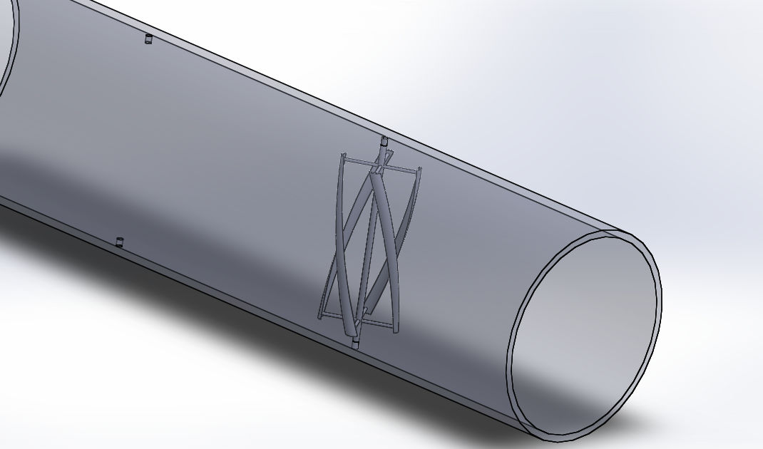
Figure 7 - Alternate Design 2 - Perpendicular axis of rotation

Initial Design Alternative 4
A vertical axis turbine with vertical blades was the fourth consideration. This design featured twelve blades perpendicular to the direction of air flow. The blade profile was set as an arc in order to capture the air flow on one side of the turbine and not introduce resistance on the other side. This design was decided against because the vertical axis turbine introduced large pressure drops across the system due to the direction of rotation. Figure 8 is a model of this design.

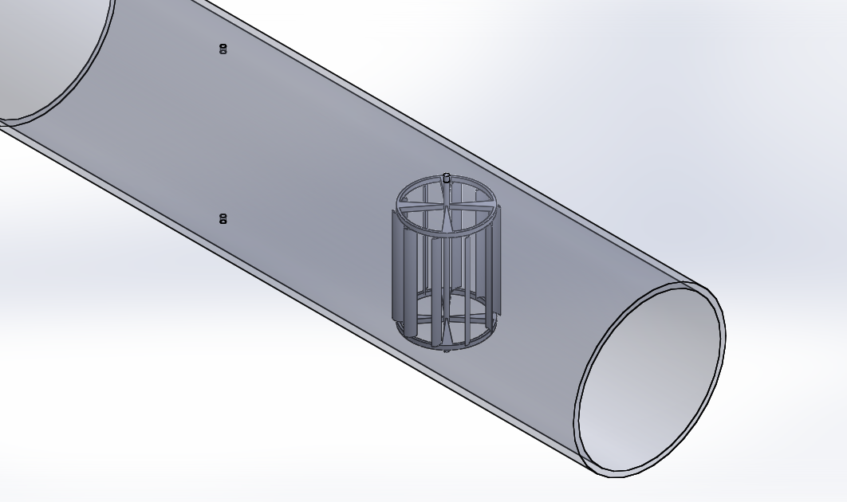
Figure 8 - Alternate Design 3
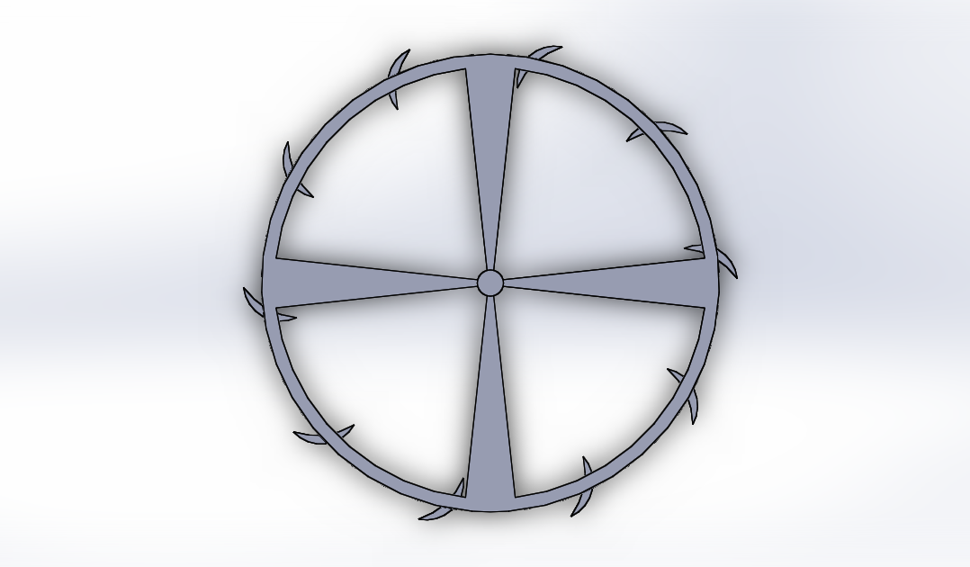
Figure 9 - Alternate Design 3 - Top View
Figure 9 shows a top view of the design. The blades have been installed at an angle to increase the force applied by the air flow. However, as the blades rotate around, the back side of the blades move against the air flow, creating unnecessary restrictions.
After analysis our first initial four designs, we decided to go with an alternate style of turbine, the helical turbine. The main issue that was a common factor with the first five designs was that it would require additional parts such as gears to transmit power of the spinning turbine. Also the fabrication of having the turbine fixed inside the exhaust pipe would be a difficult task due to the size to the pipes that were planned to be used. The decision was made to pursue the helical turbine design for the two advantages of easiness of rapid fabrication and the ability to be able to run multiple tests as well. It was extremely important to gather data and validate our results for the success of the project.

Initial Helical Design Concepts
In our alternate design considerations, we chose to have multiple variations of blade designs to have a better understanding on how the different designs would have behave with the air flow it would experience. Three different designs were designed through SolidWorks.

Initial Helical Design 1
This design consists of 6 blades along the inner cylinder in which each blade rotates 90⁰ as shown in Figure 10 in an isometric view. In Figure 11 we see the front view of the turbine and it shows that the blades take up 30% of the cross sectional area of the circle. This was kept consistent for design 1 and design 2.
Figure 10 - Isometric View of Helical Design 1

Figure 11 - Front View of Helical Design 1

Initial Helical Design 2
For the second design, 4 blades were used along the inner pipe and each blade rotated 90⁰ along the pipe as shown in Figure 12. In Figure 13 it shows the front view of the design 2 in which we again see that the blades take up 30% of the cross sectional area of the inner cylinder.
Figure 12 - Isometric View of Helical Design 2

Figure 13 - Front View of Helical Design 2

Initial Helical Design 3
In the third design we used only two blades in the inner pipe and each blade rotated 180⁰ as shown in Figure 14. This design would use less material but may not be the most optimal design due to the aggressive degree of rotation of the blade. Also it takes up 40% of the inner cross sectional area which will restrict the airflow more that in the previous two final designs. Figure 15 show the front view of design 3. This would be the predicted inferior design which we will be testing in SolidWorks.
Figure 14 - Isometric View of Helical Design 3

Figure 15 - Front View of Helical Design 3

Test Data & Manufacturing of Initial Helical Designs
In order to do initial testing, the turbines in Figure 10 and Figure 12 were 3-D printed as shown in Figure 16 and Figure 17. After the printed parts were out and there was a physical representation of what was designed it was realized that the blades did not coved enough cross sectional area or have enough of an aggressive angle to make them rotate. It would also have to be re-designed in order to fit the specific bearing that was purchased. There was no further testing done with these three initial helical turbines due to the alternate modifications that would be made in the final design considerations. Although these turbines were not tested, it was an important step in figuring out the direction of our project.
Figure 16 - 3-D Printed 6 Blade Design

Figure 17 - 3-D Printed 4 Blade Design

Manufacturing
In our prototype manufacturing, the materials and tools used were readily accessible at local hardware stores. In order to replicate the exhaust and the working conditions as accurate as possible, we replicated what a section of the exhaust would look like with our added turbine. The pipes were simulated by using PVC pipes and they were cut to size to represent the left and right side of where the turbine is placed. Figure 19 shows the pipes in the blue color and the turbine in the middle. The turbine will be made on a 3-D printer and attached to the PVC pipes using two bearing. The bearings which are the black portion in Figure 19 will keep the turbine tightly sealed and stable.
A cylindrical copper coil will be placed around the spinning turbine in order and around the cylindrical turbine there will be magnets placed in order to generate electricity. The size of the magnets will have to be small and powerful in order to generate a sufficient amount of electricity. We will be using neodymium magnets with an N48 grade which is the highest grade available to purchase. Further research and testing has to be done to make a final design decision. The copper coil is not depicted in either Figure 18 or Figure 19 but it will be part of our future design as the project continues.

Figure 18 - Front View of Design

Figure 19 - Isometric View of Design

Preliminary Final Designs & Testing

Apparatus
The testing was done with the Technavate Vari-speed multi-fan Distribution Apparatus in the transport lab in F.I.U as seen in Figure 20. The apparatus was used to try and replicate different airflows in order to measure the velocity, Reynolds number, and the pressure differences caused by the multiple final designs. Three different designs were used, along with three different pipe diameters representing the different car/truck pipes used in modern cars today.

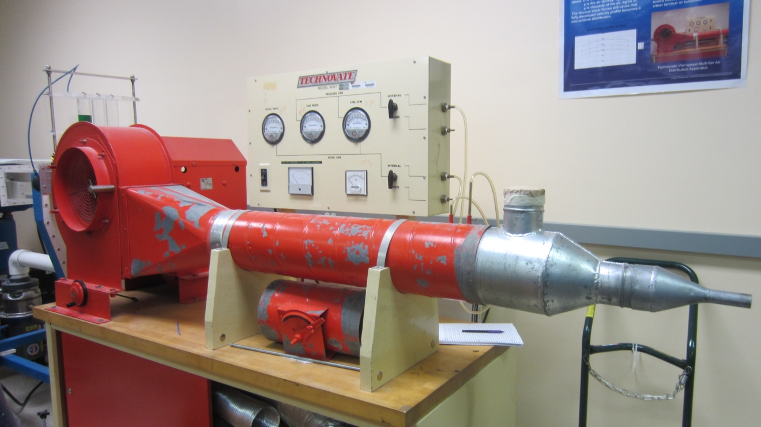
Figure 20 - Apparatus (Technavate Vari-speed multi-fan Distribution Apparatus)

Bearing Used In Testing of Turbine A and Turbine B
The bearings used were two single row deep groove ball bearing. They are from the company ORS Bearing and were able to be purchased locally in Miami. The outer diameter is 62mm and the inner diameter (bore) is 35mm. The outer diameter of the bearing is what will be fixed to the inner diameter of the turbine. The process of how it will be held as of now is to squeeze the bearing into the turbine by force so it will hold in place. The inner diameter of the bearing will also be fixed to outside diameter of the pipes in the same manner as previously stated. Figure 21 shows the basis of the assembly in which we arranged the designed project.
The bearing have a felt seal made out of steel plates which is beneficiary because it has less friction than if we were to use rubber seals. Another benefit of it being made of steel is that since it will be exposed to a high temperature, it is less likely to fail, whereas the rubber one would deform and damage the bearing. Our goal is to have the least friction so that when the airflow runs through the pipe and hits the turbine, it will cause the turbine to spin as freely as possible. This is our first major step of the project. Table 1 shows the specifications of the bearing we choose according to the direct manufacturer’s website.
Table 1 - Bearing A Specifications
Attributes | Values
Bearing Type | Open
Bore Dia | 35mm
Outer Dia | 62mm
Width (B) | 14mm
Max Speed (Grease) (X1000 RPM) | 11
Max Speed (Oil) (X1000 RPM) | 13
Ball Qty | 11
Ball Dia (Dw) | 7.938
Weight (g) | 155
Precision | A1
Standard Clearance | C0
Material | Chrome Steel

Turbine A
Turbine A as seen in Figure 23 was designed to fit into the bearing (A) tightly. The inner diameter of the turbine was 35mm in order to have exact match to the bearing inner diameter. Also matching the bearing and the turbine, was the diameter of the pipe at 35mm. Super glue was used to attach the pipe to the bearing as shown in Figure 21. Two bearings we purchased along with two pipes in order to have a backup and in order to also test different lubricants to reduce the bearing friction. After testing both lubricant types which were made by the same company (Liquid Wrench), the best one that made the bearing spin the best was the one marked with “penetrating oil” which is designed with cerflon. It can be seen in Figure 22 on the right hand side with the yellow marking.
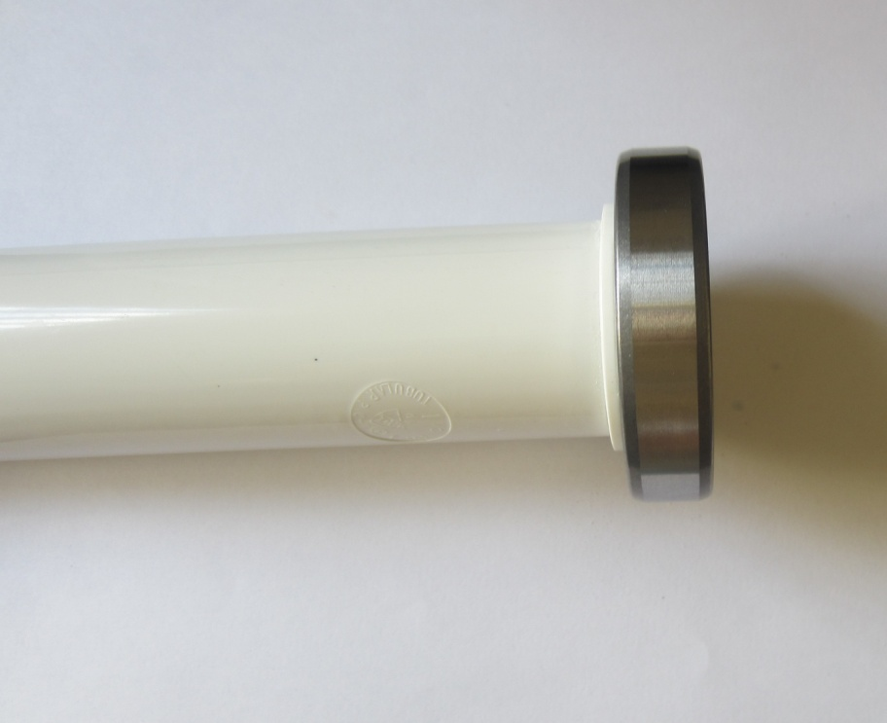
Figure 21 - Bearing attached to pipe

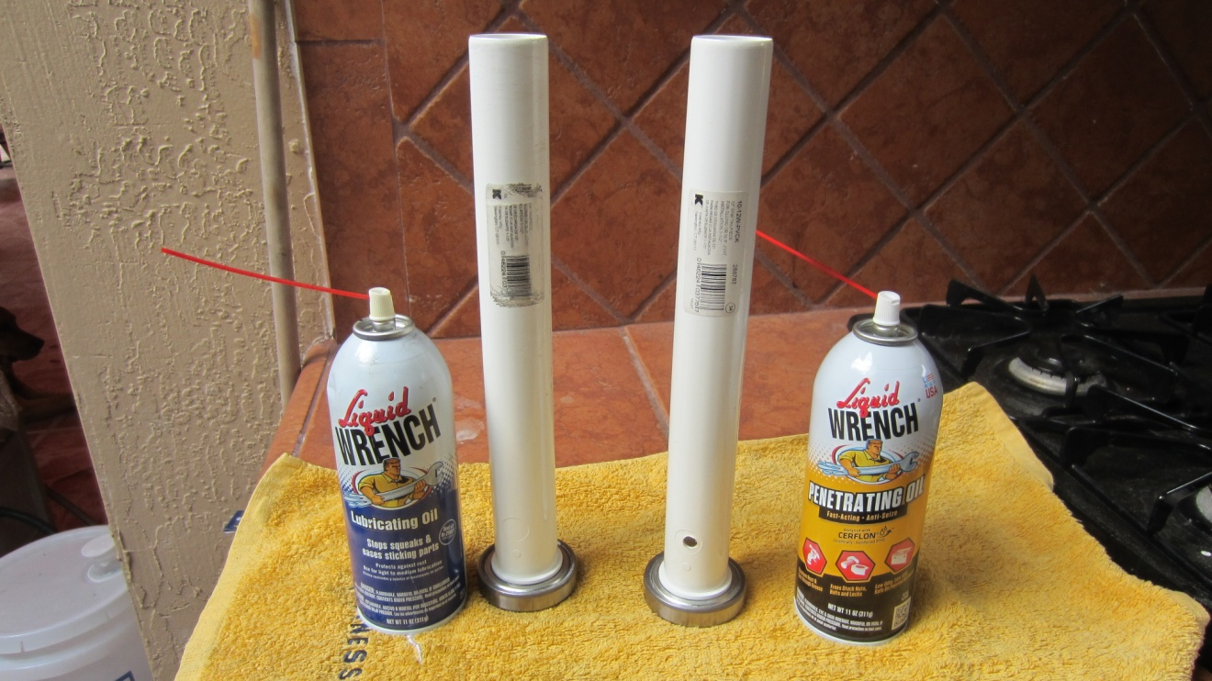
Figure 22 - Testing Pipes and Bearing

Now that the best possible spinning bearing was determined, the testing could begin. Turbine A was attached to the bearing and it was tested with the apparatus as the air flow went through it.

Figure 23 - Turbine A

Testing of Turbine A
Apart from the apparatus used for testing, a Pitot tube was used for all our measurement of velocity and pressures at different air flows. Figure 24 shows the Pitot tube used to perform the experiment and it was provided in the lab.
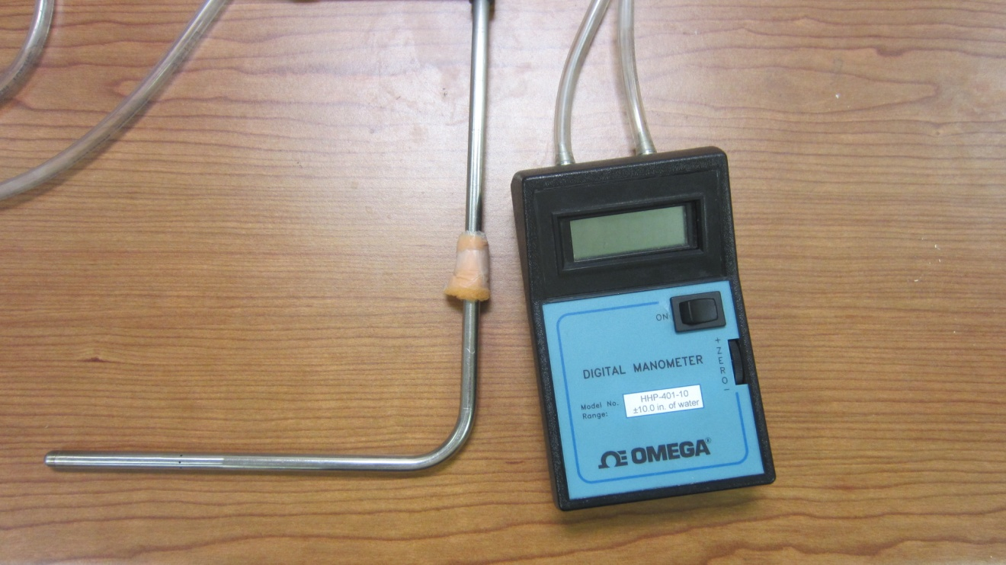
Figure 24 - Pitot Tube Used for Experiment
The pipe and turbine A was put in front of the duct of the apparatus to gather different readings of pressure at different airflows as seen in Figure 25. Before the turbine was added, pressure readings were taken in order to compare the difference in pressure change. The closer that difference is in percentage, the less back pressure it will cause back into a car’s engine.
Figure 25 - Testing of Turbine A

In Table 2 and Table 3 it shows the difference in pressure prior to adding the turbine to the pipe and then after adding the turbine. Five measurements at each amp setting were taken in order to obtain the most accurate results possible. It shows a huge increase in pressure, having an increase of 110% from the baseline pressure reading which is in no way optimal. This meant that another re-design of the turbine must be done. The problem with turbine A is that the surface area where the air flow first hits the blades was to small which didn’t allow the turbine to spin much and at the same time was creating a large amount of back pressure.

Table 2 - Gathered Data of Pressure without Turbine
Pressure without Turbine (Inches of Water)
AMPS | 9 | 10 | 11 | 12
 | 0.96 | 1.12 | 1.34 | 1.43
 | 0.99 | 1.15 | 1.36 | 1.38
 | 0.97 | 1.17 | 1.42 | 1.41
 | 1 | 1.18 | 1.29 | 1.47
 | 1.02 | 1.09 | 1.34 | 1.45
AVERAGE | 0.988 | 1.142 | 1.35 | 1.428

Table 3 - Gathered Data of Pressure with Turbine (A)
Pressure with Turbine (A) (Inches of Water)
AMPS | 9 | 10 | 11 | 12
 | 1.97 | 2.49 | 2.84 | 3.07
 | 1.99 | 2.47 | 2.85 | 3.04
 | 2.02 | 2.5 | 2.76 | 3.05
 | 2.01 | 2.44 | 2.91 | 3.13
 | 2.03 | 2.41 | 2.83 | 3.1
AVERAGE | 2.004 | 2.462 | 2.838 | 3.078

Turbine B
In the case of Turbine B as shown in Figure 26 the inner cross sectional area that the turbines take up was much greater than that of Turbine A. The turbine spun well but still created a large amount on back pressure.
Figure 26 - Turbine B

Testing of Turbine B
In Table 4 it shows the pressure reading with Turbine B added to the pipe. It had a 53% increase of pressure, which was better improvement over Turbine A, but still nowhere close to an efficient goal of back pressure that would not affect the engine.

Table 4 - Gathered Data of Pressure with Turbine (B)
Pressure with Turbine (B) (Inches of Water)
AMPS | 9 | 10 | 11 | 12
 | 1.53 | 1.78 | 2.01 | 2.08
 | 1.52 | 1.79 | 2 | 2.13
 | 1.59 | 1.8 | 1.96 | 2.11
 | 1.55 | 1.83 | 2.03 | 2.12
 | 1.58 | 1.74 | 1.97 | 2.17
AVERAGE | 1.554 | 1.788 | 1.994 | 2.122

In order to see the changes in pressure between Turbine A and Turbine B with comparison to the base line pressure before adding any of the turbines, Figure 27 was assembled. It shows the difference in pressures but future work will get us closer to a successful turbine design where the percentage of increase of pressure will be minimal and not affect the engine with back pressure.

Figure 27 - Pressure Difference Between Turbine A and Turbine B

In Figure 28 it shows Turbine A and Turbine B 3-D printed with the view of where the airflow enters the turbine. This shows that the cross sectional area on Turbine A where the airflow initially makes contact is less that in Turbine B. It is in this relation that it can be determine why Turbine B spun much better than Turbine A and also caused less back pressure to the system. In Figure 29 it shows the area were the airflow exits the turbines and again it shows that Turbine B has a greater cross sectional area of the blades than Turbine A, further concluding the better spinning of Turbine B.

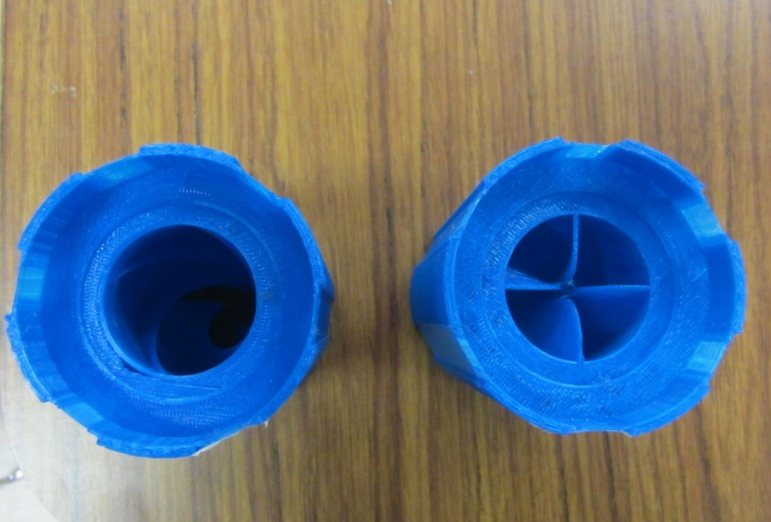
Turbine A
Turbine B
Figure 28 - Comparison of Printed 3-D Models (Inlet of Turbine A and Turbine B)
Turbine B
Turbine A
Figure 29 - Comparison of Printed 3-D Models (Outlet of Turbine A and Turbine B)

With the conclusion of the testing of Turbine A and Turbine B, there were a few derived alternatives to improving the design in order to reduce the back pressure. Since Turbine B was successful in spinning almost as twice as much as Turbine A, the group decided to keep the same design of the blades in Turbine B. The major change that was made was to increase the diameter of the inner diameter of the inlet for the turbine. The inner diameter used to test both turbines was 35mm, which is a small pipe comparable to that of a small vehicle. This was not giving the result we were trying to achieve so it was decided to go to 56mm which is a 60% increase in diameter. This diameter size is representative of a small truck exhaust pipe. The focus was changed to pursue the testing of a bigger pipe diameter such as a small truck. This would increase the pressure at the point of the inlet where the airflow hits the turbine to increase spin.
Another realization was that the bearing being used had too much friction and was making it hard for Turbine A and Turbine B to spin smoothly. The bearing size and style were changed. An ultra-thin bearing was chosen for the final senior design turbine which is further discussed in the following section.

Final Design

Figure 30 - Final Designed Turbine on SolidWorks

Figure 30 shows a model of the finalized turbine design. The grooves along the length of the turbine are channels in which the magnets are inserted. Because the magnets are required to be oriented with poles facing in the same direction, the magnets naturally repel from each other within the channels, resulting in them being evenly spaced throughout. There is an area through the center of the turbine which is unobstructed by the blades, allowing for a portion of the flow to move freely.

Figure 31 - 3-D Printed Final Design Turbine

Once the magnets were added to the internal channels in the turbine, it was noted that the weight of the turbine caused occasional instability. As a result, the proposed final design will include a second bearing as support to stabilize the rotation.

Bearing Used In Testing of Turbine
The bearing used with the final assemble is shown in Figure 32. It’s made by RBC and it a thin section ball bearing. It’s made out of 52100 steel and the weight is 90.7g which is significantly less that the first bearing weighing in at 155g. The outer diameter is 88.9mm and the inner diameter is 76.2mm.
Figure 32 - Bearing Used in Final Assembly

Testing of Final Turbine Design
For the testing of the final designed turbine, the same process that was used to test Turbine A and Turbine B was used for this turbine. The turbine was place in front of the air flow of the apparatus and it spun amazingly well. Once the team acquired this great result, the testing began and much data was collected. For each amp measurement tested, five data points were taken to ensure better accuracy and a clear representation of the experimental dat. In Table 5 the readings of pressure are taken before the addition of the turbine in order to have a base line reading to be able to compare the pressure changes when the turbine is added. The average to the five data points was taken to have an accurate figure.

Table 5 - Pressure in Inches of Water before Turbine is Added
Amps | Pressure (Inches of water) |  |  |  |  | AVERAGE
9 | 1.60 | 1.57 | 1.58 | 1.55 | 1.57 | 1.574
10 | 1.87 | 1.84 | 1.86 | 1.90 | 1.92 | 1.878
11 | 2.13 | 2.14 | 2.09 | 2.11 | 2.14 | 2.122

In Table 6 it shows the readings takes once the turbine has been added to the system and again the averages were taken at each setting for the amps enabling the airflow. Between Table 5 and Table 6 it can be seen that the averages from the readings before the turbine is added and after it was added are almost identical. This means that our group finally succeeded in having barely any back pressure added back to the system with the introduction of our new turbine in to the exhaust pipe.

Table 6 - Pressure in Inches of Water after the Turbine is added
Amps | Pressure (Inches of water) |  |  |  |  | AVERAGE
9 | 1.58 | 1.59 | 1.61 | 1.56 | 1.54 | 1.576
10 | 1.91 | 1.96 | 1.97 | 1.93 | 1.93 | 1.940
11 | 2.13 | 2.11 | 2.15 | 2.16 | 2.08 | 2.126

With the data gather so far, Figure 33 was plotted in order to show how the pressure plots behaved and with this it can be further evidence of the success of the designed turbine. At 9 amps there is a 0.13% change, 10 amps a 3.30% change, and 11 amps a 0.19% change. That gives an average of 1.21% change in pressure.

Figure 33 - Pressure Comparison Before and After Adding the Turbine

With the success of the project thus far, our group continued further testing of the turbine to examine different relations. Using a tachometer, the RPM’s were taken five different times to ensure the most accurate results in Table 7. Figure 34 shows the plotted result. This can be used as a reference for further testing at different airflows.

Table 7 - RPM Readings for Turbine with Different Air Flows
Amps | RPM |  |  |  |  | AVERAGE
9 | 336 | 338 | 346 | 350 | 340 | 342
10 | 639 | 644 | 642 | 656 | 662 | 649
11 | 724 | 718 | 722 | 725 | 711 | 720

Figure 34 - Relation of RPM's vs. Amps

Our team wanted to obtain as much information relating to our experiment, so the velocity and the Reynolds number was also calculated for our experimental testing. In order to get the air flow velocity, the Pitot tube was used to get ΔP at the center of the pipe size used which again was 56mm in diameter. Once that was obtained, the velocity could be calculated using Equation 1. Since the measurements where in inches of water in had to be converted to Pascal. 1 inch of water = 249.174 Pascal. With this conversion and using the density of air at 21ºC (room temperature) to be 1.2 kg/m³, the velocity was obtained in m/s. Also calculated was the Reynolds number as a way to determine if the flow way laminar or turbulent. For that, Equation 2 was used where D = diameter of the pipe and v = kinematic viscosity at room temperature. With this, Table 8 was made to show the velocity and Reynolds number for the 56mm pipe. In Figure 35 and Figure 36 it shows the velocity and the Reynolds number for the different fan speeds. The flow for the testing is in the turbulent state as the Reynolds number is above 2300.

Equation 1 - Velocity of air flow
$$V=\sqrt{\frac{2(ΔP)}{ρ_{air}}}$$

Equation 2 - Reynolds Number
$$Re= \frac{DV}{v}$$

Table 8 - Calculated Velocity and Reynolds for Diameter of 56mm Pipe
AMPS | Δ P Readings (Inches of Water) |  |  |  |  | AVERAGE | VELOCITY | REYNOLDS
9 | 1.55 | 1.53 | 1.5 | 1.51 | 1.48 | 1.514 | 25.1 | 22053
10 | 1.85 | 1.86 | 1.81 | 1.89 | 1.92 | 1.866 | 27.8 | 24483
11 | 2.13 | 2.12 | 2.14 | 2.21 | 2.17 | 2.154 | 29.9 | 26304

Figure 35 - Velocity at 56mm Pipe as the Amps Increased

Figure 36 - Reynolds at 56mm Pipe as the Amps Increased

Transfer of Electrical Power
Thus far, the experiment on our final designed turbine resulted in very promising measurements. The next step our team needed to approach was the issue of getting the turbine to generate electrical power using electromagnetic forces and copper coils. As seen in Figure 30, there are six channels designed into the outer diameter of the turbine. In each of these channels 4 magnets were placed side by side in an opposing polarity fashion. This provided an optimal way of attaching the magnets onto the turbine without having to use any kind of adhesive to keep the magnets in place. This configuration also allowed each magnet to have same poles pointing radially outward with respect to the cylindrical surface, allowing for the induction of current in the same direction throughout each coil. Once all the magnets were in place, a cap was designed to cover the holes where the magnets were slid into. The cap was then super glued onto the tip of the turbine to keep all six rows of magnets in place. Figure 31 shows the tip of the turbine completely sealed with the cap. All the magnets were already in place in any prior results so no additional comparison would have to be done.
Based from the research of Faraday’s law of induction, the idea to generate electrical power directly was to have oval coils placed around the perimeter of the turbine, in parallel with the length, so that the magnet poles would be facing towards the coils’ central holes. As the turbine start spinning, the electromagnetic field created by the magnets would perpendicularly cut through each of the wire cross section and induce a current throughout the whole length of the coil. The direction of current would theoretically changes from positive to negative as the magnet is brought towards and away from the coils respectively. Therefore, a bridge rectifier was needed in the circuitry to convert the natural AC output into a DC current in order to charge a battery. To initially prove the theory, one coil was used in preliminary testing to determine how much current and voltage a single set of 500 turns would produce. Using a multi-meter, the voltage and milliamps were measured and recorded. Figure 37 shows the single coil around the turbine for the preliminary testing.

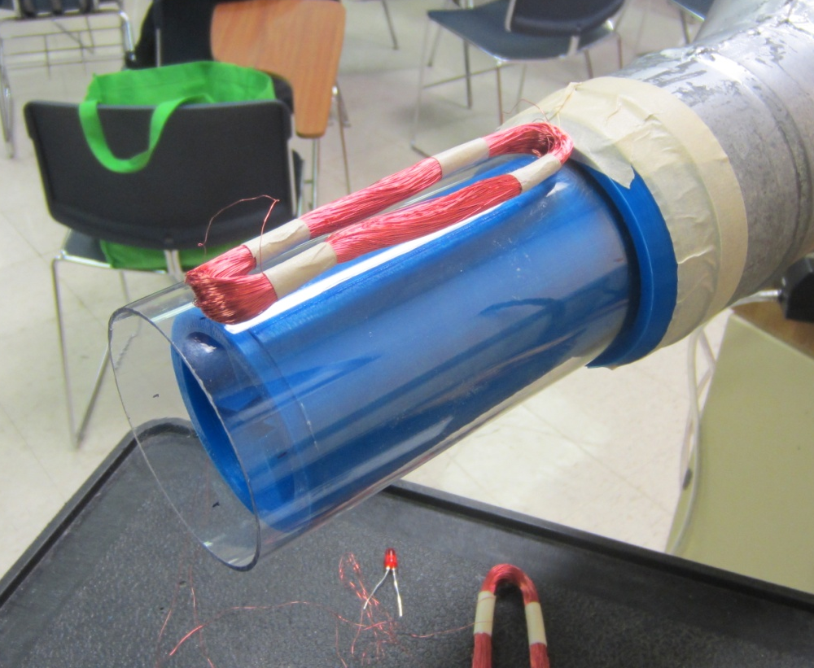
Figure 37 - Coil outside the Turbine to Determine Current

For the measuring of the voltage, five different readings were taken to get an average. The more readings taken, the more accurate the results were. In Table 9 it shows that with the higher amps, the voltage increased. From this preliminary testing, generating electricity was successfully obtained.

Table 9 - AC Voltage Readings of One Coil
Amps | AC - VOLTAGE |  |  |  |  | AVERAGE
9 | 1.6 | 1.7 | 1.6 | 1.7 | 1.7 | 1.66
10 | 2.7 | 2.4 | 2.5 | 2.6 | 2.7 | 2.58
11 | 3.1 | 3.4 | 3.3 | 2.9 | 3.6 | 3.26

Flow Rates
The testing has been performed at different volume flow rates from the air distribution system. In order to determine if the results can be considered accurate, the volume flow rates from the system must be compared to the flow rates of engines at realistic operating speeds. Table 10 shows the volume flow rates calculated based on the Pitot tube readings at the three different air speeds.

Table 10 - Air Distribution System Volume Flow Rates
Volume Flow from Air System
Amps | Velocity (m/s) | Diameter (mm) | Flow (L/s)
9 | 25.1 | 56 | 61.8
10 | 27.8 | 56 | 68.5
11 | 29.9 | 56 | 73.6

These rates are compared to volume flow rates from different size engines at typical operating speeds. The engine sizes range from 5 liters to 10 liters, covering trucks from commercial pickup trucks to semi-trucks. The volume flow rate was calculated based on the number of exhaust cycles per revolution and a specific engine speed. The engine speeds selected were chosen based on typical cruising rotation speeds for the particular vehicle type. Table 11 shows the calculated volume flow rates for the different size engines. The volume flow rates used for testing correlate to the typical flow rates that can be expected from vehicles. In most cases, the flow rate at cruising engine speed is significantly higher than the flow rates used for testing.

Table 11 - Engine Volume Flow Rates
Flow from Trucks
Engine size (L) | Engine Speed (RPM) | Flow (L/min) | Flow (L/s)
5 | 750 | 1875 | 31.3
5 | 2000 | 5000 | 83.3
5 | 3000 | 7500 | 125.0
6.7 | 2000 | 6700 | 111.7
6.7 | 3000 | 10050 | 167.5
8 | 1000 | 4000 | 66.7
8 | 1500 | 6000 | 100.0
10 | 1000 | 5000 | 83.3
10 | 1500 | 7500 | 125.0

The next step was to determine the proper circuit configuration that would generate the most electrical power from the coils. A set of one, two, and six coils were chosen to test in a combination of series and parallel connections. Table 10 shows the measurements obtained from the experiment in voltage and milliamps, which was then multiplied together to determine their respective wattage. From the results of this experiment, it was concluded that the series configuration was providing a significant increase in power as compared to the parallel configuration. From this observation, we decided to connect our 6 coils in series for the testing of the final assembly.

Table 12 - Electrical Outputs in Different Coil Configurations
Configuration | AC Volts | DC Volts | DC mA | Power mW
1 coil | 1.8 | 1.5 | 10.7 | 16.05
2 coils series | 3.7 | 3.3 | 13.5 | 44.55
2 coils parallel | 1.7 | 1.6 | 15.5 | 24.8
All coils series | 13.5 | 12.2 | 14 | 170.8
All coils parallel | 1.8 | 1.53 | 28.6 | 43.758

The last step for the electrical testing was to have all six coils placed around the turbine in order measure the final electricity generated. Figure 38 shows the final SolidWorks conceptual model of attaching a clear tube onto a multi-coupler that would act as a housing to attach the copper coils. Figure 39 reveals the final assembly of the housing with the 6 coils in place that would encompass over the spinning turbine, which can also be seen in complete assembly in Figure 40. When assembling the turbine housing, each coil needed to be spaced evenly at 60 degree angle steps throughout the circumference of the tube in order to properly provide a relatively close matchup of the spacing between the magnet rows. In this manner, a simultaneous induction of current would occur on all the coils at the same time, allowing for greater generation of power.

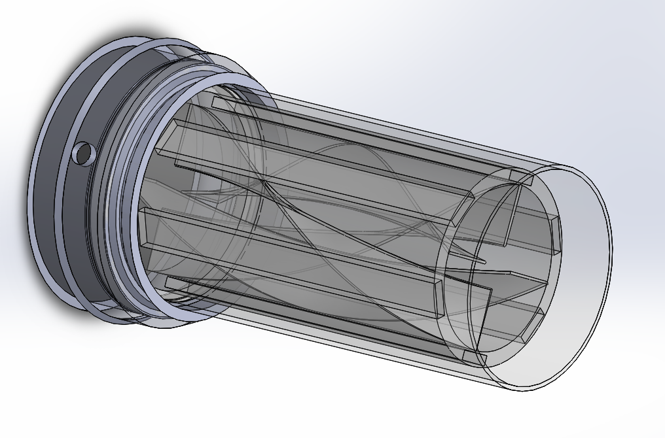
Figure 38 - Model of Final Assembly on Solid Works
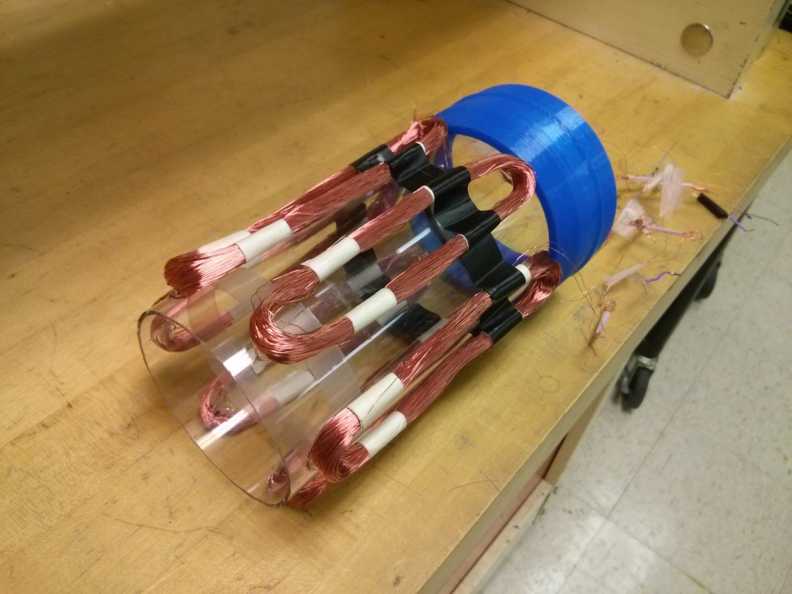
Figure 39 - Final Assembly of Turbine Housing
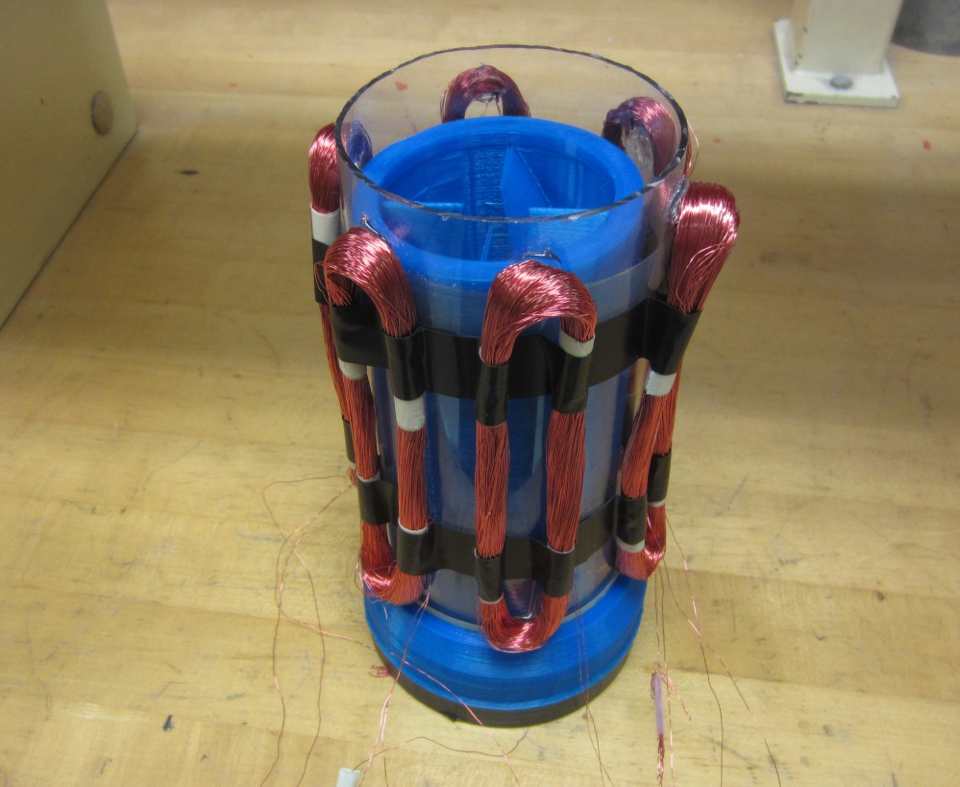
Figure 40 - Final Assembly of Turbine Design
Figure 41 shows the set up for the final testing of power generation on the finalized turbine design. In this experiment, the turbine was decided to be placed on a vertical position rather than horizontal in order to more accurately replicate the positioning of exhaust pipes found in larger working trucks. The results of the experiment, found in Table 11, show that the turbine design was able to generate an acceptable amount of electrical power at an average of 533.76 milliwatts at optimal airflow speeds.

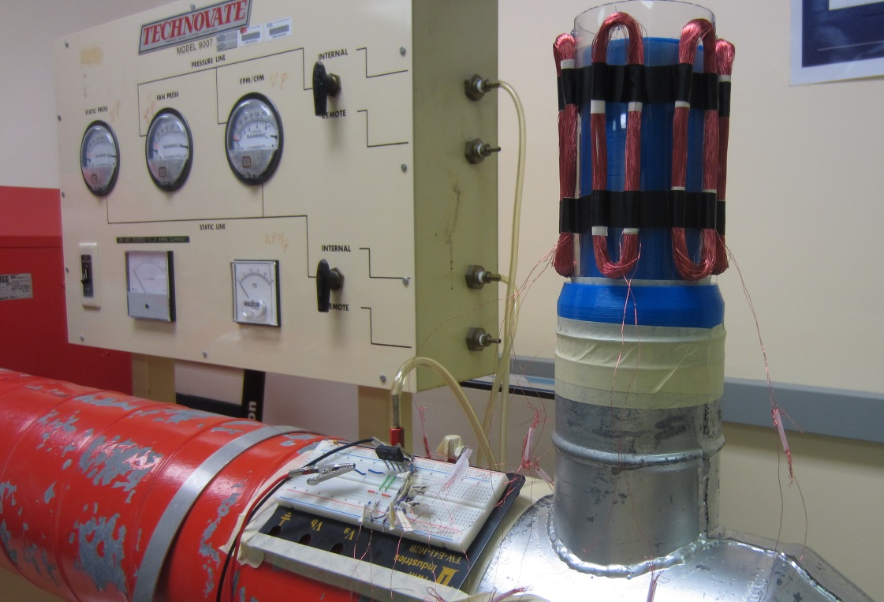
Figure 41 - Apparatus for Final Assembly Testing

Table 13 - Electrical Output at Maximum Speed and Magnetism
Configuration | AC Volts | DC Volts | DC mA | Power mW
1 coil | 2.50 | 2.21 | 22.70 | 50.16
6 coils in series | 18.75 | 17.98 | 29.69 | 533.76

This final experiment was able to prove the concept that a helical shaped turbine design can indeed generate an adequate amount of electrical power from the an airflow source without causing a significant increase in back pressure that would otherwise hinder the system’s efficiency.

Project Management
The major components of the project have been divided among the members based on subject matter expertise.

Timeline
The timeline for the project spanning a seven month period is shown in Figure 42. The minor components of the project have been grouped into larger phases to generate the timeline.
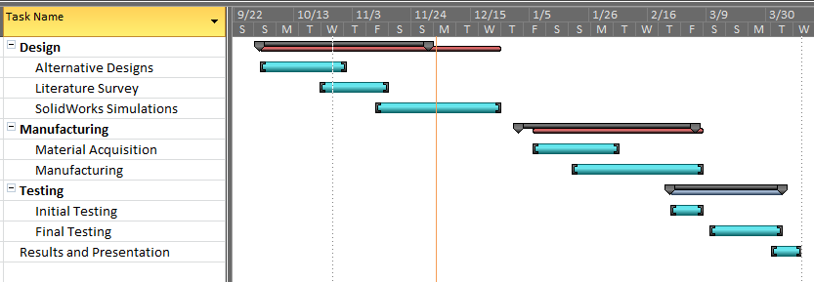
Figure 42 - Project Timeline

Table 2 outlines the expected timeline for the major components of the project. The initial testing is expected to begin early in order to complete the simulations and select the most efficient design of the turbine profile.

Table 2 - Timeline
Design | 10/1/2013 | 11/29/2013
Alternative Designs | 10/1/2013 | 10/31/2013
Literature Survey | 10/22/2013 | 11/15/2013
SolidWorks Simulations | 11/11/2013 | 11/29/2013
Manufacturing | 1/6/2014 | 3/7/2014
Material Acquisition | 1/6/2014 | 2/5/2014
Manufacturing | 1/20/2014 | 3/7/2014
Testing | 2/24/2014 | 4/4/2014
Initial Testing | 2/24/2014 | 3/7/2014
Final Testing | 3/10/2014 | 4/4/2014
Results and Presentation | 4/1/2014 | 4/11/2014

Major Components

Blade Material Selection
The material selection of the turbine designed had to take into consideration the temperatures that will be present in the exhaust. For the positioning of the turbine, it will be placed toward the ends of the exhaust pipe as opposed to being closer to the engine where the temperatures are highest. For conventional passenger cars the temperature at the end of the exhaust pipe is typically 200°-250°C. This provides us with a good starting point to make a material selection. Further information can gathered on the types of cars and the temperature range for the exhaust pipes for more accuracy with the analysis. Table shows the different types of materials considered for the designed turbine along with the melting points (Metals - Melting Temperatures). The aluminum alloy meets the requirement for the temperature conditions in which the turbine will be placed in the exhaust pipe. In future designs, if the turbine is place closer to the engine, there are other material which can be used based on the temperature increase. Iron and steel can both sustain temperatures over 1000°C in case that’s a design condition pursued.

Table 3 - Material melting points
Material | Melting Point (°C)
Aluminum Alloy | 463 -671
Carbon Steel | 1425 - 1540
Gray Cast Iron | 1127 - 1204
Stainless Steel | 1510
Titanium | 1670

Structure Material Selection
In order to minimize the area occupied by the turbine support, a strong material such as aluminum will be considered. Many types of metal will be analyzed based on the expected air flow velocity, temperature, and likelihood of corrosion. The weight of the material selected is important in both getting the turbine to rotate and also maintain rotational velocity once air flow has decreased.

Copper Coils
Due to the structure of the turbine and the enclosure, standard copper coils could not be purchased. The coils were to lie along the length of the turbine, with the selected magnets along the length of the gap within the coil shape. For this reason, the coils were to be wound manually. Due to the rather low current expected from the system, a thin 30 gauge wire was selected. This thin wire allowed for more rotations of the coil without occupying a large space or creating unnecessary weight along the enclosure. Each coil is composed of 500 coils of the thin wire to ensure consistency across all coils.

Magnets
In order to achieve the highest amount of power from the rotating turbine, strong magnets were required. For this reason, neodymium rare earth magnets were selected. Although not the strongest rating of N52, the magnets selected were of grade N48. For the purposes of this project, the slight decrease in strength was assumed to be negligible. The shape of the magnets affects how the power is transmitted to the copper coils. Initially, disc shaped magnets were considered. However, after reviewing the layout of the magnets along the length of the turbine, rectangular magnets were decided upon. Aside from selecting the shape of the magnets, the orientation of the two poles was critical. The poles must face perpendicular to the face of the turbine. The final magnets selected were eighth inch thick rectangular magnets, one inch in length and one half inch in width. The poles of the magnets lie on the large faces of the rectangular prism.

Structural Design
The final structural design will be based on the optimized model built and analyzed. The support of the turbine will be minimized in volume to prevent unnecessary volume flow restrictions. The support may be designed utilizing an air foil type design to assist with the redirection of air flow. The bearings selected will also be chosen based on the size of the bearing which will not restrict air flow. The shape and orientation of the blades will be closely analyzed to optimize the amount of energy conversion while minimizing the pressure drop across the system.
Based on simulations, an enclosure for the bearings and gears may be required to lubricate the joints and prevent failure. The turbine axis will be designed with a slight diameter increase over the length of the shaft to deter air flow from the gear assembly.

Cost Analysis
The consideration of the cost for the parts is based on the desired prototype that will be built in order to determine the effectiveness of turbine designed. The turbine will be 3-D printed with PrintrBot FDM printer which our group currently has, therefore introducing no additional cost associated to the printing of the turbines. The material used to print the turbine is PLA (polylactic acid) which is a polymer. The material itself costs roughly $2 for the multiple pieces so that cost is substantially small and was not accounted for. In Table 3 is the breakdown of the component that will be required to build a prototype for experimentation and comparison to SolidWorks simulation.
The clear PVC pipe is to simulate an exhaust pipe of an automobile and since it is clear, it is easy to see the turbine spinning which can help with future design considerations. Since the turbine will be spinning, the bearing will make the motion very smooth for optimal efficiency. The tool that may be required is a small drill to secure the housing for the turbine to be pipe as well as other miscellaneous parts can’t be determined at this time.

Table 14 - Prototype Materials
Parts | Cost
3D Printer | $700
Bearings | $82
Pipes | $20
Coils | $38
Magnets | $53
PLA Material | $30
Lubrication | $12
Miscellaneous | $50
TOTAL | $955

In this group, every member contributed equally with their time and efforts. Table 15 shows the breakdown of the hour distribution per member that is expected to take place through the completion of the project. This estimate is done based on the hours already spent during the first half of the project. Our final estimation was 420 hours, which calculated at $35 per hour, gives us a total labor cost of $14,350.

Table 15 - Engineering hours
 | Brian Gleason | Angel Fernandez | Efrain Rivero
Task | Hours | Hours | Hours
Project Formulation | 2 | 3 | 3
Prototype Design | 7 | 8 | 7
Possible Designs | 9 | 10 | 10
Design | 8 | 11 | 13
Testing and Analysis | 12 | 13 | 14
Solid Works Modeling | 30 | 20 | 20
Solid Works Analysis | 35 | 32 | 31
Prototype Assembly | 9 | 10 | 10
Component Research | 8 | 9 | 12
Cost Analysis | 10 | 12 | 10
Report Writing | 10 | 12 | 10
Total Hours Per Person | 140 | 140 | 140
Total Project Hours | 420

Prototype

Cost Analysis
The prototype of the turbine will be manufactured utilizing Fused Deposition Modeling (FDM). This method will allow the cost of materials and manufacturing to be lower than that of different types of metals such as aluminum and titanium. The material commonly used by noncommercial FDM machines is Polylactic Acid (PLA), a thermoplastic polymer. This material will be used to produce the prototype blades and costs $30 per kilogram.
For the real life prototype, the turbine will be made out of aluminum alloy. Further research will have to be done as to which type to use but as far as the working temperatures of the exhaust pipe, aluminum has a melting point over 400° C. Also, since our group was not able to experiment with the high temperatures associated with the exhaust pipes, it is hard to determine the outcome of the material selection. The biggest concern for us would be the bearing which its highest operating temperature is between 150°C-175°C. This may cause further issues in the future of the design and this has to be further investigated.

Testing Plan
Initial testing will consist of a computational fluid dynamic analysis of the built model. This will assist in determining which blade profiles and configurations will produce the best results. In order to properly simulate an exhaust pipe, a simulation will first be performed using an empty pipe to determine the mass air flow. This mass air flow will then be used to determine the pressure drop once the system is installed. The pressure difference between the two simulations will provide the expected outcome.
In order to test the worst case scenario, the simulations will be performed on a blade which is not rotating. This will cause the bigger restrictions, and closely simulate a large sudden increase in air flow. Simulations will also be performed with the blades in motion and with varying air flow velocities to better reproduce realistic scenarios.
Testing the prototype of the exhaust turbine will consist of measuring the drop of pressure across a three inch tube with the system towards the output of the pipe. A pressure meter will be placed between the input of the tube and the turbine system to read the pressure as the speed and flow increase. The testing will be performed at different speeds to simulate the varying speeds of the engine. A volt meter will be attached to the alternator which is on the output shaft of the turbine system.

Conclusion
The need for better utilization of energy systems continues to be a growing issue as the world becomes more dependent the technologies that considerable consume energy today. The search for more efficient energy systems, such as in powertrains of automobiles, have become a more important field of interest. Recent government regulations have demanded for better fuel consumption in the coming decades for automobile manufacturers. Because of this great demand, our team proposed to harvest the energy from the power system of automobile through the exhaust gases exiting the tailpipes that would otherwise be wasted. Our solution was to use of a turbine blade design that would be driven within the flow of the exhaust gas in order to generate additional electric power that would be put back into the system. Our initial design was to use different number of helical shaped blades that would be positioned axially to the direction of flow of the gas and attached axially to a central shaft that would spin inside the tailpipe. The design was then altered to sustain these helical blades circumferentially instead of axially in order to make the transfer of the power generated more effortlessly though the actual rotation of the outer walls of the cylindrical duct. It was decided to attach magnets along the outer surface of this spinning cylinder to produce changing magnetic fields that would induce electrical current directly onto a set of coils following the principle of Faradays law of magnetic induction. This unique approach to transmitting the power generated was concluded to have less friction loses as compared to mechanically connecting an alternator onto the rotating surface. The use of these magnets also proved to avoid moment forces that would otherwise exist from a mechanical connection to a generator. An ideal set of coils and turns were chosen to effectively generate a sufficient amount of electric power without causing too much resistant onto the rotation of the spinning duct.
An important element in the testing of our new design was to determine how much back pressure our turbine designs would be imposing onto the exhaust system in order to decide whether it would be an acceptable about that would not affect the overall efficiency of the engine. Through our experimental results, an acceptable value of 1.21% increase in backpressure was concluded to be produced through the addition of our blade design. To compensate for the small amount of back pressure being generated onto the system, our coils were able to generate 1.3-3.5 volts each at respective flow velocities, which would be able to produce an overall increase on the efficiency of automobile powertrain.
Through the results of our experiment, our design was a complete success in being able increase the overall efficiency of an energy system such as was in the case of applying it onto an automobile. Future applications could be expanded to other areas of high air flow such as the output of a home air conditioner, the exhaust of a household drier, or building vents.

References
Where The Energy Goes. (2007). Retrieved from US Department of Energy: http://www.fueleconomy.gov/feg/atv.shtml
Aeristech. (2012, February 27). FullElectric Electric Turbocharger Technology . Retrieved from Aeristech: http://www.aeristech.co.uk/full-electric-turbocharger-technology
Alternative Fuels Data Center. (n.d.). Retrieved from US Department of Energy: http://www.afdc.energy.gov/data/10301
EPA. (2012, October 15). Regulations & Standards. Retrieved from EPA: http://www.epa.gov/otaq/climate/regs-light-duty.htm
Freedman, & Young. (2004). University Physics. San Francisco: Pearson.
Kawamura, H. (1987). Patent No. 4,694,654. United States of America.
Metals - Melting Temperatures. (n.d.). Retrieved from The Engineering Toolbox: http://www.engineeringtoolbox.com/melting-temperature-metals-d_860.html
NHTSA. (2012, August 28). Obama Administration Finalizes Historic 54.5 mpg Fuel Efficiency Standards. Retrieved from NHTSA: http://www.nhtsa.gov/About NHTSA/Press Releases/2012/Obama Administration Finalizes Historic 54.5 mpg Fuel Efficiency Standards

